Assessment: In-Lab Exercise 01

Student Name: Yiyang, Xia

Lab Professor Name: Zeinab Bayati

Lab Section Number: 333

Due Date: 09-18 09:50

# Task 1

Step2

We need change the position of 03 and 04

Step 3

Start

declarations

string employee

double salary

double bouns

double sum

output"Enter your name"

input name

output"Enter your base salary"

input salary

output"Enter your bonus amount"

input bouns

sum = salary + bouns

output"Hello "employee" Your total payment is " sum "."

Stop

# Task 2

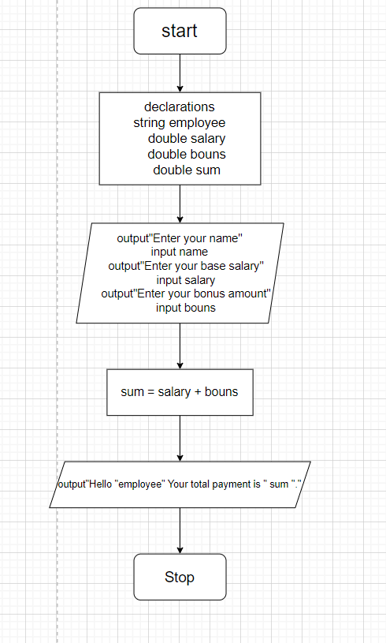

# Task 3

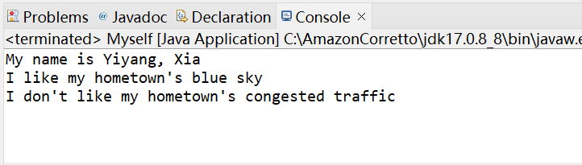

# References / Sources Cited (optional section as needed)